# Usability Summary

The GreenFood Organic Application has been developed with careful consideration of Nielsen’s 10 User Interface (UI) Heuristics, to ensure a seamless user experience.

These UI Heuristics are outlined below:

Each of these design heuristics have been applied in various ways throughout the application.

## 1. Visibility of System Status

Visibility of System status has been incorporated through the ensuring users know what screen they are on and whether their edits have been added to the system.

## 2. Match between system and the real world

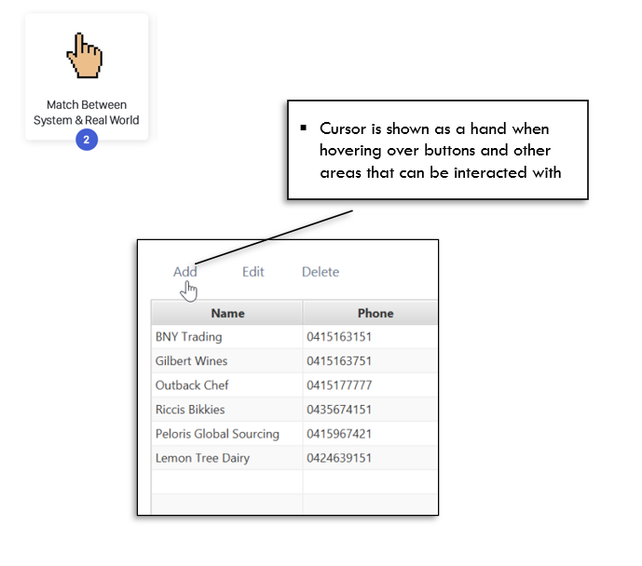

Matching between system and real world have been considered by using natural designs such as corresponding addition to a plus sign.

## 3. User control and freedom

User Control is found through clear exit (logout) and easy ways to undo and redo actions through delete or editing entries.

## 4. Consistency and Standards

Consistency and Standards are found through single side menu bar for employees and suppliers as well as common symbols and styling for buttons which provides consistency.

## 5. Error Prevention

Error Prevention is found through confirmation pop-ups, which appear when the user attempts to delete an item from a list. This prevents the accidental deletion of list items.

## 6. Recognition rather than Recall

Recognition rather than recall is found through recognisable symbols next to buttons, which allows intuitive navigation throughout the application

## 7. Flexibility and efficiency of use

Flexibility and efficiency of use is found through the minimalistic UI, which makes the application straightforward to use. It is also seen through the application of the 3-click rule, where all screens can be accessed in 3 clicks.

8. Aesthetic and Minimalist Design

Aesthetic and Minimalist Design can be seen through the appropriate use of whitespace, to ensure that the screens are not cluttered.

## 9. Help users recognise, diagnose and recover from errors

Help provided to manage errors is found through an error message on the login screen that appears if a user makes an error inputting information. This is used to guide the user on the error they have made.

## 10. Help and Documentation

Help and Documentation can be found in the ‘About’ section of the side menu bar, which contains information at the copyright statement, and all third-party libraries & multimedia items included in the application.